data: facts, text, graphics, images, etc

database application: application programs

constraint: a rule that cannot be violated by database users

repository: centralized storehouse for all data definitions

metadata: includes data definitions and constraints

data warehouse: integrated decision support database

information: data placed in context or summarized

user view: logical description of portion of database

database management system: a software application that is used to create, maintain and provide controlled access to user database

data independence: separation of data description from programs

database: organized collection of related data

Enterprise resource planning: a business management system that integrate all functions of enterprise

SDLC: a structured, **step-by-step** approach to system development

prototyping: a **rapid** approach to system development

enterprise data model: a graphical model that shows the high-level entities for the organization and relationships among those entities

**conceptual** schema: a comprehensive description of business data

**internal** schema: consists of two data models: a **logical** model and physical model

**external** schema: consists of the **enterprise data model** and multiple user views

composite attribute: can be broken into component parts

associative entity: relationship modeled as an entity type

unary relationship: relates instances of a single entity type

weak entity: depends on existence of another entity type

* + does not have a unique identifier, partial identifier have double lines
* Strong entity
  + exists independently of other types of entities
  + has its own unique identifier
    - identifier underlined with single line
* Identifying relationship
  + links strong entities to weak entities

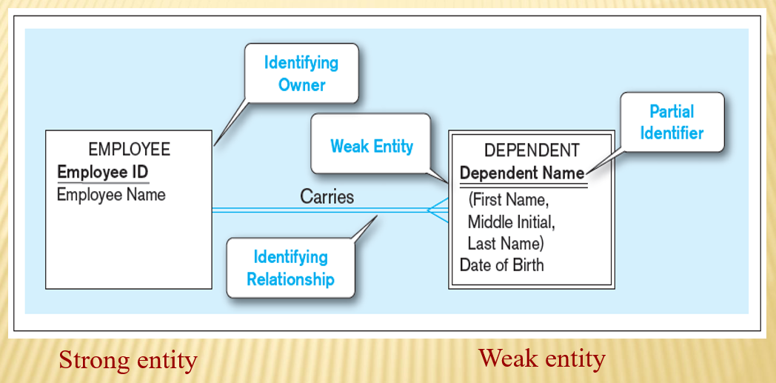

attribute: property of an entity

entity: person, place, object, concept, event

relationship type: association between entity types

* + The relationship type is modeled as lines between entity types…the instance is between specific entity instances

cardinality constraint: specifies maximum and minimum number of instances

degree: number of participating entity types in relationship

identifier: uniquely identifies entity instances

entity type: collection of similar entities

ternary: relationship of degree 3

* **Entity instance – A single occurrence of an entity type**

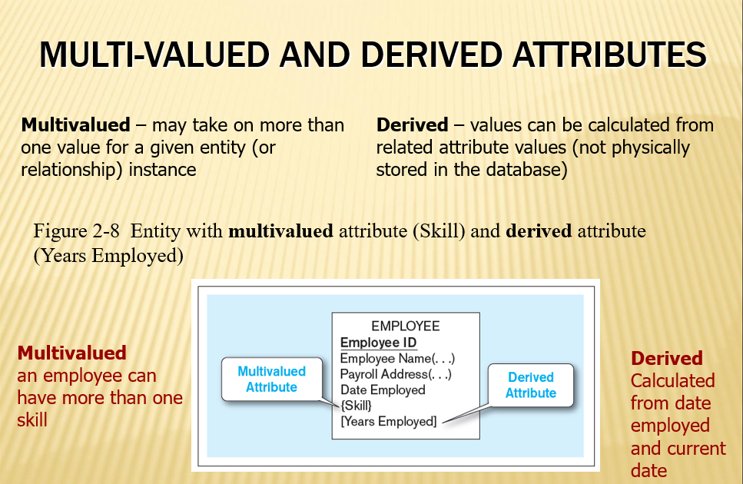

* **Identifier (Key)–an attribute (or combination of attributes) that uniquely identifies individual instances of an entity type**

